**“Tutorial-5**

**1.Design a Form like below. When user Click on OK Button it will print “Welcome to First Windows Application” on Label. When User Click on Cancel button form get closed.**

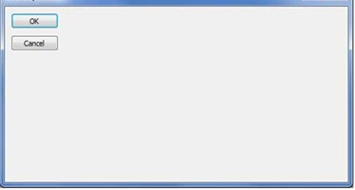

**Code:**

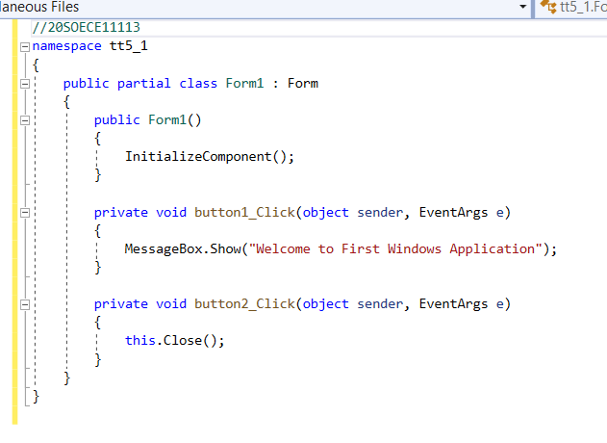

**Output:**

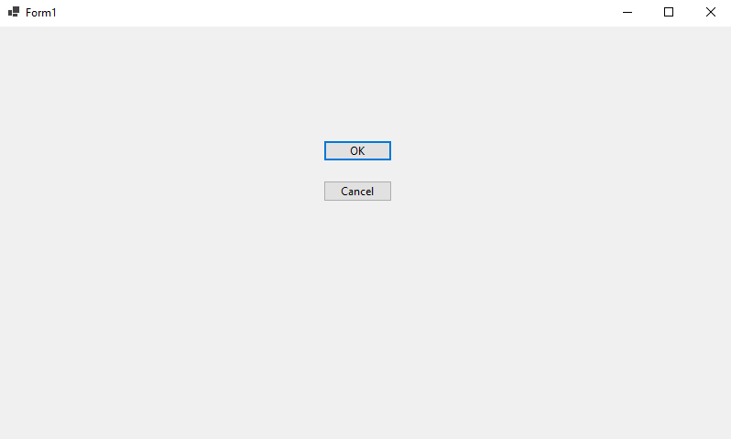

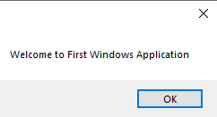

**2.Design a Form like below. When user click on Send Message Button it will display combine message like below on label:**

**“Message of <<Name>> from <<Organization>> with <<comment>>”**

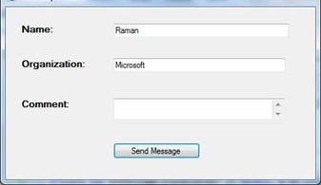

**Code:**

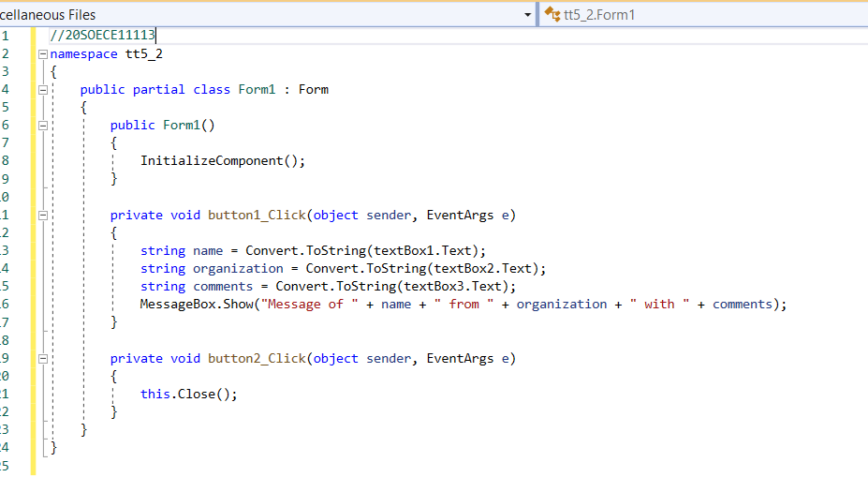

**Output:**

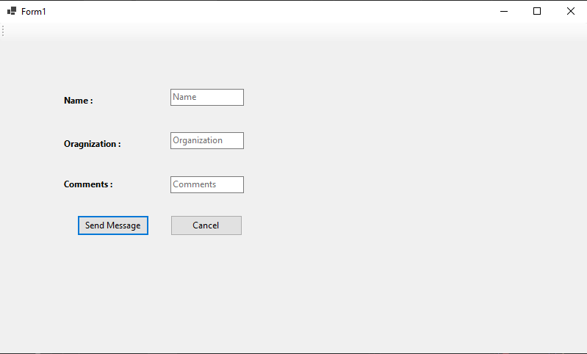

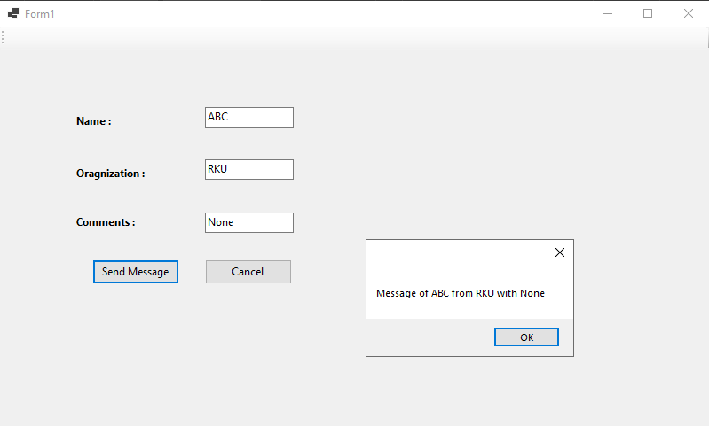

**3.Design a form like below. Depends on User’s selection, Background color and Fore Color of Form will change.**

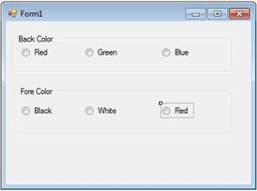

**Code:**

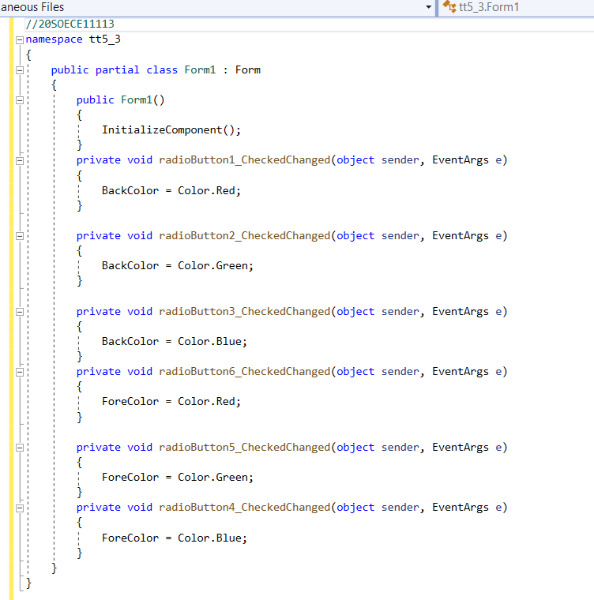

**Output:**

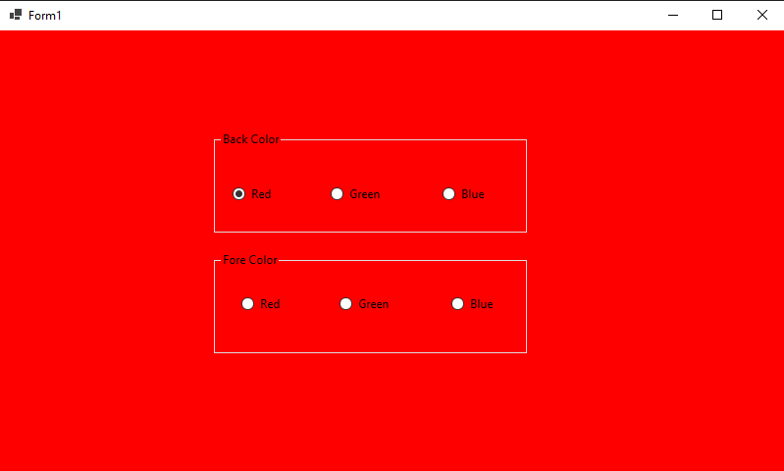

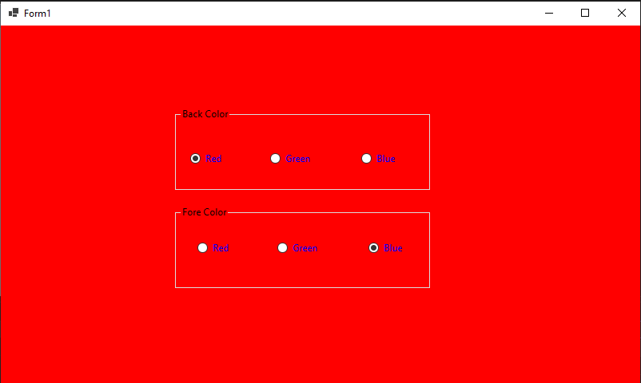

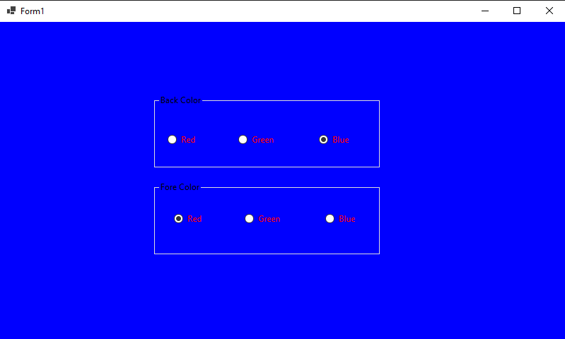

**4.Design a form like below. When user click on Answer button, selected operation performed on given two numbers and answer is displayed on as shown.**

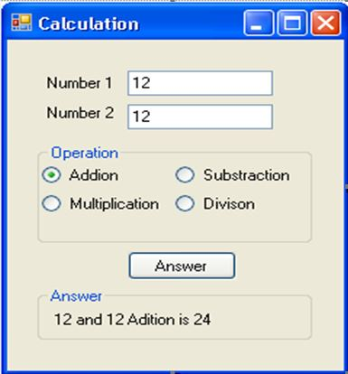

**Code:**

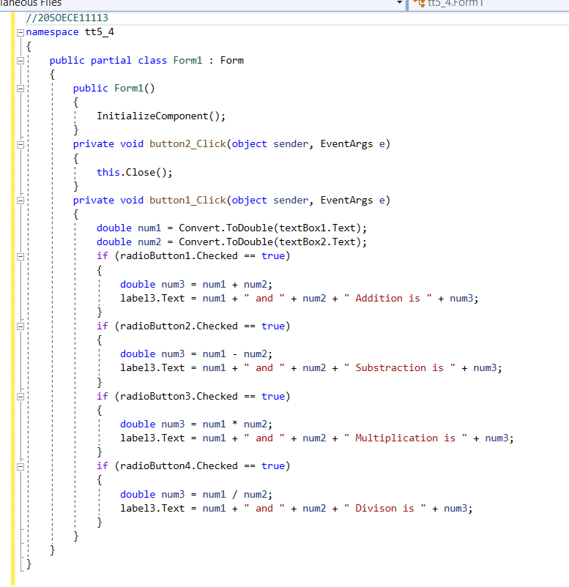

**Output:**

